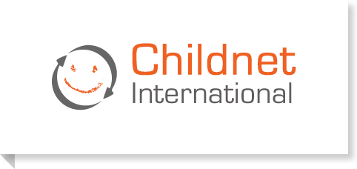

Welcome to Childnet International’s website. The internet is an amazing place and a wonderful resource and our aim is to help make the internet a great and safe place for children and young people. Find the latest information on the sites and services that you like to use, plus information about mobiles, gaming, downloading, social networking and much more.
Please use the links below:
https://www.childnet.com/resources
https://www.childnet.com/parents-and-carers
https://www.childnet.com/young-people

