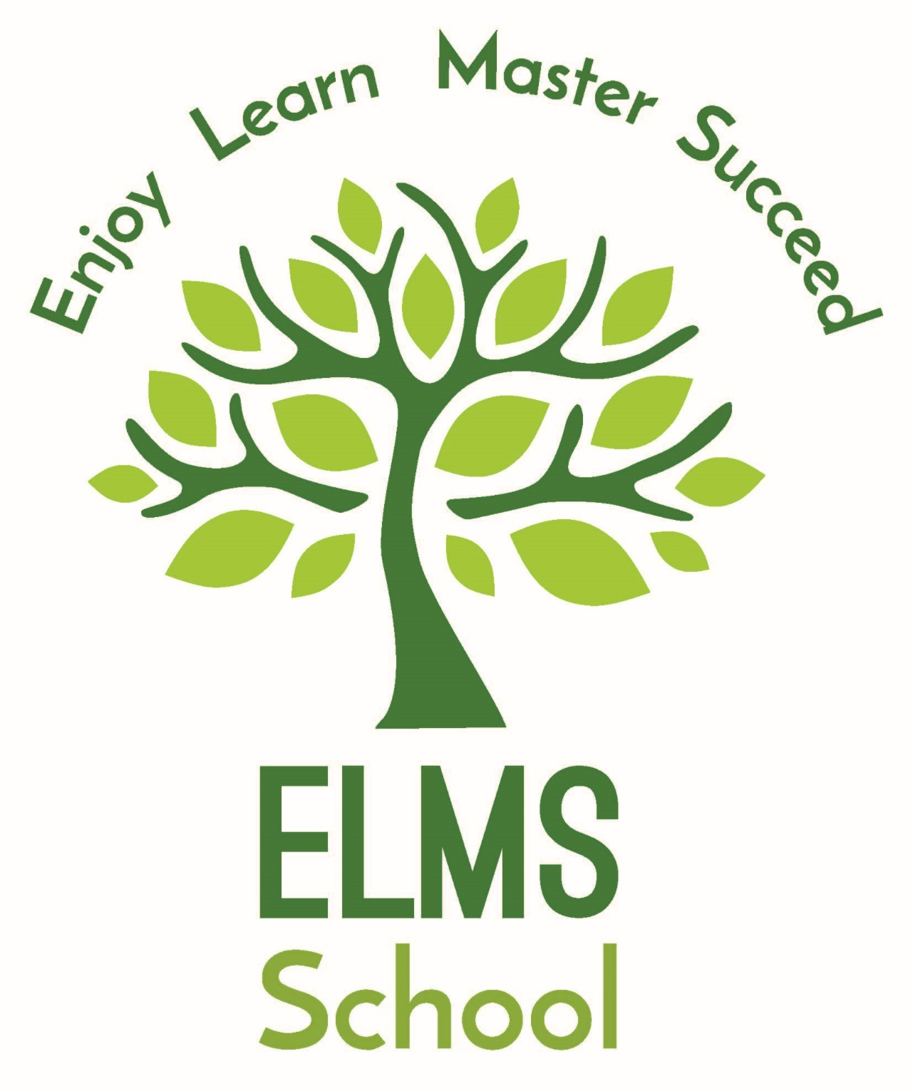
Enjoy Learn Master Succeed

Elms School Education Policy

Acronyms
FBV Fundamental British Values
EYFS Early Years Foundation Stage
KSent Kent Special Education Needs Trust
SLT Senior Leadership Team

Overarching principle of our Education Policy

The statutory entitlement of every pupil to an education that is in alignment to the 2014 National Curriculum and is designed to reflect the needs of our school and the wider community.
The Aims of our Education Policy
- To deliver a knowledge engaged curriculum so all pupils can build upon their knowledge and skills in a sequential manner
- To make learning exciting
- To put learning to read phonics and developing reading skills at the heart of our academic curriculum
- To offer curriculum challenge and curriculum support so all our pupils can Enjoy, Learn, Master and Succeed at Elms School
- To build a whole school reading culture where we celebrate our pupils’ reading skills and build a personalised
- Library around our pupils’ interests
- To nurture our pupils’ interests to encourage them to develop a lifelong desire to keep acquiring and being curious about the world they life in
- Ensure the wider academic curriculum offer PSHE/RSE develops our pupils’ emotional, social understanding of the school as a community
- To provide a broader, richer curriculum by access to a Forest school, a Duke of Edinburgh award, work of charities, educational trips to areas of local interest, geography field trips
- To erase any cultural capital deficit by providing specialist subject enrichment days
- To ensure all pupils understand the Fundamental British Values ready for their life in modern Britain
- To ensure pupils reach their potential and make appropriate rates of personal progress
- To continue to develop a wide examination offer ensuring opportunities for all pupils to acquire accredited outcomes for the next step of their learning journey
- To continue to grow the school’s careers programme to fully prepare for the next stage of their education post 16

Curriculum Model
As a teaching body we have taken great care to design our curriculum to achieve our vision-to provide all our pupils with a rich curriculum. The curriculum has a defined model, ‘knowledge engaged’. This model was deemed the ‘best fit’ for the Elms curriculum model from the following models: knowledge led, skills based and innovative curriculum. The curriculum includes the following core National Curriculum subjects: English, Maths, Science and the National Curriculum foundation subjects: Computer Science, PE, Art, Design and Technology, Cooking and Nutrition, History, Geography, RE, PSHE-RSE and a MFL in KS2. There is a whole school curriculum with detailed knowledge and skills progression for each subject and subject assessment frameworks. The whole school curriculum is arranged where possible by a topic focus. The teachers use the whole school curriculum, subject knowledge and skills and assessment frameworks to inform their own mid-term planning.
All curriculum, knowledge and skills and assessment framework updates are discussed and actioned in the five Faculty Groups: Communication, Maths and Technology, Science and PE, Humanities and the Creative Faculty. The Faculty leads have overall responsibility for setting the budget requests. Currently, the Communication Faculty holds an Arts Mark for Literacy & Numeracy and the Creative Faculty hold a silver Art Mark. The school is working towards the PSHE Quality Mark, The Wire Award and maintaining The Balanced System.

Curriculum Intention
Each subject specialist built upon the subject and knowledge from year 1 to year 11 exit examination at the end of year 11. This will always be reviewed because of continued curriculum changes, for example EYFS 2021, and exam board syllabuses. At Elms school there is a commitment to effective transitions from school to school and from year 11 to post 16+ learning journey. Historically, the career’s programme has always been a strong feature of the transition to and progress on college courses, alternative placements with careful monitoring of pupils post 16.
Curriculum Implementation
The classrooms at Elms have clearly defined pedagogical approaches that are in play in a variety of classrooms-constructivism is used predominantly, but not exclusively in the lower school. A more collaborative/enquiry based approach is evident in middle school and flourishes in the science lessons.
The teachers create opportunities for creative classroom so that our pupils become active participants and at the same time provide differentiated resources and targeted interventions to support learning for all pupils. As a school we are committed to recognizing and creating opportunities for our most gifted and talented to shine within the curriculum. This is monitored by the Head of Inclusion.
Our teachers aim to inspire. All teachers engage with delivering learning through digital interfaces and this is shaping the way ahead for education in the school. All teaching and learning promotes opportunities to build cultural capital as well as developing a deeper awareness of Fundamental British Value.
Where possible the learning is taken outside the classroom and opportunities are planned to incorporate the local environment. We have secured partnerships with local providers and this supports our curriculum offer. Our teachers seek opportunities to collaborate with other subject teachers or within their own school phase. The creative Arts afternoons are an example of teachers coming together for a shared aim-school Christmas production.
Throughout Key Stage 1 and 2 a wide variety of teaching and learning approaches to engage pupils but with the upper school there is a different teaching style designed to foster pupils’ learning independence by supporting examination coursework task. In the upper school there is a more reflective and integrative approach which allows pupils step back from their learning and look with a critical eye and make the connections across subjects.
Teaching and Learning
All teachers are supported to deliver exciting, engaging lessons. The HT/DHT have created and continually update the ‘Top Tips to Learning at Elms School’. This is shared with teachers and is a benchmark of best classroom practice across the three phases of the school.
- All lessons to be well planned with a clear structure
- Learning objectives and success criteria shared
- Learning objective understood and misconceptions addressed
- Planning shared with teaching assistants with their role clearly defined
- Teaching assistants to support learning as well as behavior
- Teacher as expert and time shared with all pupils
- Impart deep subject knowledge and/or skills
- Hook the pupils’ interest at the start of the lesson
- Meaningful and rich activities that develop pupils’ knowledge and/or skills
- Differentiated, bespoke learning resources so every pupil can achieve
- Extra resources to allow all pupils to access the learning, for example: white boards, timelines, manipulatives and light boxes
- Prior and current learning is systematically checked throughout the lesson
- Timely feedback throughout the lesson ensuring every pupil is involved at all stages and further misconceptions addressed
- Future learning: where this lesson fits into prior learning, current learning and future learning: ‘sequential.’
- Pupils to interact with the lesson content, questioning and sharing idea with peers.
- Foster a positive learning environment where behavior is addressed in a positive manner, using the PBS approach of 4:1 positive comments, so reference to consequences in the behavior policy are minimal.
- The school Code of Conduct, Rewards, learning points and house points support the learning ethos.
Impact of the Curriculum
At Elms school there is a culture of high expectations, each pupil is baselined as they join Elms school regardless of the age they enter the school. The tracker’s algorithm predicts the end of year 11 examination grades.
Throughout the year there are three data pinches; the data is analysed in relationship to the personal progress targets of each pupils. The DHT conducts progress meeting with each class teacher and subject teacher. The meeting celebrates the pupils’ results and if there are concerns a pupil is not making appropriate progress with the quality first teaching, the inclusion manager will provide an academic intervention for English, Maths or a Holistic Intervention-Thrive, Forest School, CBT and 1:1 counselling if the need is emotional and social. The Head of Behaviour can also support a class teacher with strategies, scripts to use in the classroom. The Inclusion Manager can support a teacher with ASD/SEN support. The school also support pupils with speech and language, Lego therapy and Precision teaching to support a pupil with dyslexia.
All pupils receive a twice yearly mini-report and a final yearly report.

Impact of the Curriculum for pupils identified as Gifted and Talented

Pupils identified as 'Gifted and Talented are supported and monitored by the school’s Inclusion manager. The class teachers and subject leads find opportunities to develop their gifts and talents.

Enriching our Curriculum and building Cultural Capital
Our vision for the subject specialist days is to provide an inspirational learning experiences for all the pupils and to help build their cultural capital and their understanding of the wider world. Our aim is to enable pupils to ask questions and seek further subject knowledge. As a school we also celebrate traditions that are important to our country and community.
As a whole school we celebrated the royal wedding Harry and Megan with a tea party and rather old fashioned games. We celebrated VE day in the first lockdown! The school has an annual Pumpkin Picking visit with and cross-curricular activities. Our last World Book Day had an alien warship land on the school playground and a video call from out of space! We encourage our pupils’ participation with charity and support organizations. We celebrate MacMillian Coffee Morning, raised money for Children in Need all staff dressed as super-heroes. We support Sports Relief-Comic Relief were races and challenges are set. We have sent shoe boxes of essential items to Porchlight. Previously, pupils from our school were involved in ‘Keeping the flame going’ Olympic Games and the pupils and school were in the local news. National Poetry Day is celebrated, alongside Black History Week, Mental Health Week, Science Week and LGBT History Month.
At Elms school the English curriculum is a champion of Shakespeare and all pupils in the middle and upper school study a Shakespeare play. The texts are timeless and accessible to all pupils regardless of need type. The pupils are encouraged to enter writing-poetry competition and to the Houses of Parliament. Pupils have taken part in the POP- UP Literature Festival over two years with visiting authors and poets. Before Lockdown, visits to cinema and theatre linked to texts or themes studied within the English curriculum. Upper school English curriculum often linked to current affairs and news stories to support non-fiction element of the syllabus.

RWI Phonics and Reading at the heart of the curriculum

At Elms School we continue our commitment to the RWI Programme for phonic learning and we also use resources from the Language and Literacy Programme. The RWI early phonics programme is supported by ‘linked texts’ that reinforce the phonic programme. This method is also used to improve their early exposure to the world of narratives. At Elms we supplement the RWI programme with the Accelerated Reader and have a library dedicated to books to support the programme. The English department’s love of text underpins the English curriculum and the style of delivery-DART directed activities related to text to maximize pupil’s engagement with the text.

Extending the curriculum beyond the school day
The lower and middle phase of the school set Home Learning projects for the major holidays; Christmas, Easter and summer. The challenge is set to enhance the learning that is done in school as well as providing an opportunity for the children to investigate, research and present their learning in a way that they want to. The upper school are provided with revision packs.

Marking and Assessment Expectations
To support our teachers and our pupils improve as learners we have devised a simple, but effective marking and assessment policy. Time is built into the Faculty agenda for subject moderation, there are three book looks where the marking policy is moderated. Teachers are sent for wider moderation meetings for the core subjects, computer science, and the early year foundation stage, within KSent schools consortium. Our senior leader-teachers are moderating-verifying for the Pearson BTEC award in Construction, P.E and Home Cooking. The DHT, an experienced national marker will moderate the Entry Level English coursework. We support our more experienced teachers moderate for their subject for exam boards in other schools and are actively encouraging classroom teachers to become examination markers.

The overarching aim of our Assessment policy is to support our pupils’ learning by empowering them to become more resilient learners through:
- Celebrating their prior knowledge and skills
- Recognising their current knowledge-skills and achievements
- Motivating and support them to move forward by sharing assessment criteria in pupil friendly speak
- Encourage ownership of their learning through self-assessment
- Develop ownership through peer assessment
- Share the pupils’ learning targets to create a meaningful learning dialogue

Written Marking Expectations
- To give timely, weekly written feedback on pupils’ books using green pen
- The written feedback should be short and use age appropriate language
- Comments should be written neatly so that pupils can read them
- To mark to the agreed literacy standard and format ‘The Literacy Grid’

Upper, Middle and Lower Schools Marking Expectations
- To use a green highlighter to highlight where a pupil has demonstrated a skill or level of understanding.
- Any positive comments the Star to be written in green under the main text.
- To use a pink highlighter to indicate an error or area for improvement, plus a pink pen to write the Wish or Next Step on the pupils’ completed piece of work.
- Lower and Middle Schools to use a purple pen for polishing their work and making corrections
- If Deep marking will support a deeper understanding, then it is used by teachers across the three school phases
- The upper school teachers mark to exam board syllabus where exam criteria is shared with pupils and is an integral part of the learning dialogue and written feedback
- In our lower school and with our youngest pupils, our teachers will use Movement Marking capturing success and identifying the next step in the moment
- All three phases of the school mark for literacy using key codes: / Start a new sentence; //New Paragraph-leave a line; CL capital letter needed; P Punctuation . , ? ! “ ”

Presentation of Pupil’s Learning ‘They learn well and take pride in their work’ Ofsted 2019
The aim of our presentation policy is to establish and reinforce high expectations of pupils’ work across the phases, promote continuity and coherence across the three phases of the school, support our pupils’ development allowing them to ‘Thrive’ and to encourage our pupils to take pride in their work thus building their self-esteem.

4th March 2021

The Layout for pupils’ work books
Pupils to add name here if it is a worksheet
Macbeth

LO To understand the witches prophecies in the opening Act

Developing the Elms curriculum and ensuring statutory curriculum compliance
The Headteacher has the overall responsibility for all aspects of the school. The DHT has responsibility for the curriculum and teaching and learning and will follow the vision for the school set by the Headteacher. The Headteacher has the overview of the schools’ data analysis, and from this analysis the DHT conducts the data meetings where pupil progress is celebrated, learning strategies and targeted interventions are set up.
The HT with DHT map the curriculum, teaching and learning monitoring and set the Faculty, Phase meetings, Middle Leader meetings, coaching and mentoring meetings. The DHT sets the Faculty agenda and will join these meeting and discussions. The HT and DHT will set the phase meetings and join the phase meetings. The DHT set up the original Middle Leaders Action Plan and will chair those meetings. All Middle Leaders have an area to develop that will improve teaching and learning across the three phases of the school.
- The Headteacher will walk the school at the start of every mini-term and enter classrooms to engage with the pupils and their learning. The HT will address with a teacher any observations that have raised a concern
- The DHT will complete the same exercise but not at the same time. DHT will address with teachers any observations that have raised a concern.
- The DHT will complete a curriculum sweep across the three phases ensure the whole school curriculum map is being delivered
- The HT/DHT will complete “drop-ins”. The teachers are given a drop in week and HT/DHT will visit. The teachers are judged against the Elms Gold Standard. The areas observed are for: High expectations: behaviour and attitudes: planning and delivery: depth of knowledge
- The Middle Leaders conduct the ”book looks” as a way of monitoring and validating their action plan. The DHT and Head of Learning will join to monitor the marking and presentation of pupils’ workbooks
- All pupils in the lower and middle school have a portfolio folder where a piece of teacher graded English and Maths is saved. The submission of the portfolios is monitored by the DHT

The DHT’s Induction Learning Agreement covers: Training, mentoring and coaching, support packages and well-being in greater depth.

Online Safety
Within our curriculum we educate the children to use ICT safely as an integral part of the curriculum and further information is to be found on our school curriculum Online Safety.

SMSC – see separate SMSC policy
There are numerous opportunities for supporting the pupils’ Social Moral Spiritual and Cultural development through all areas of the whole school curriculum. Spiritual development is promoted through RE curriculum. Moral development is promoted through the PSHE-RSE curriculum and positive behaviour management. The range of texts within the English curriculum lead to debates on morals and morality. Pupils’ social skills are developed through their check-in circles and within the pastoral support programme. The Thrive programme also supports pupils develop their social and emotional health either on a 1:1 or whole class-based activity.

Fundamental British Values

The fundamental British Values are part of the curriculum DNA and the learning language of our classrooms. All the five Faculty subjects build in opportunities to highlight a key value (s) within the long-term whole school curriculum. In recognition of our commitment to the FB values, a whole enrichment day was dedicated to the values, with all resulting work being displayed on each classes’ FBV display board, as well as displayed outside the Head teacher’s office. The Humanities Faculty plans for further subject enrichment days that build in opportunities to raise awareness of the values.

3
Approved by Juli Timoney, Headteacher | Date 10th February 2021
Last review date | February 2021
Next Review date | February 2023

